**Scala programming**

**Name: CHETHAN Y**

**Date: 11-09-2023**

**Usn: 22BTRAD011**

**1.Write a Scala program to check two given integers, and return true if one of them is 30 or if their sum is 30.**

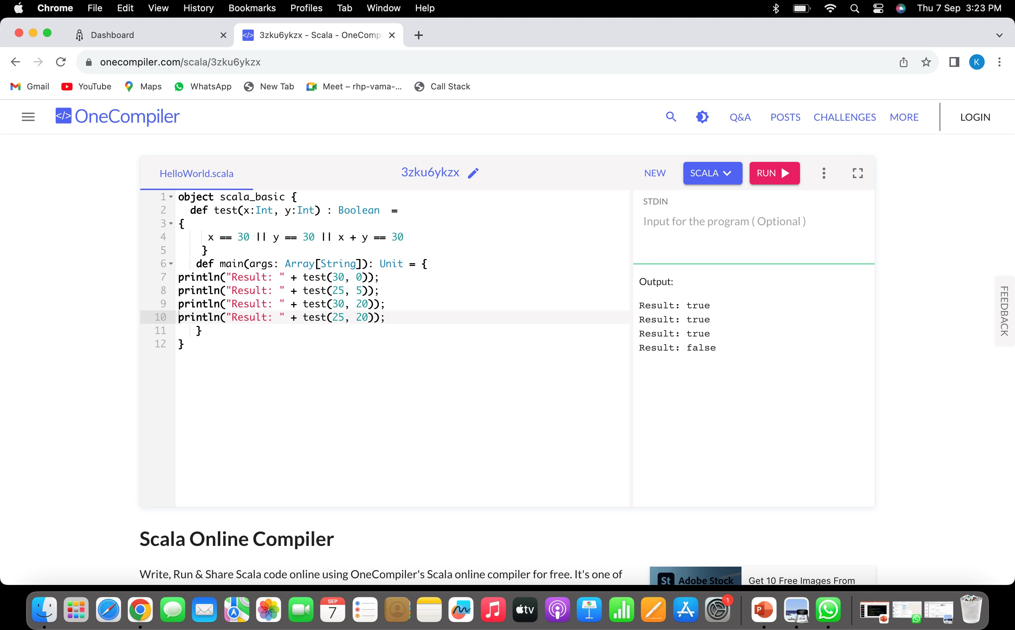

Edited 1 ,printing the greater value in given

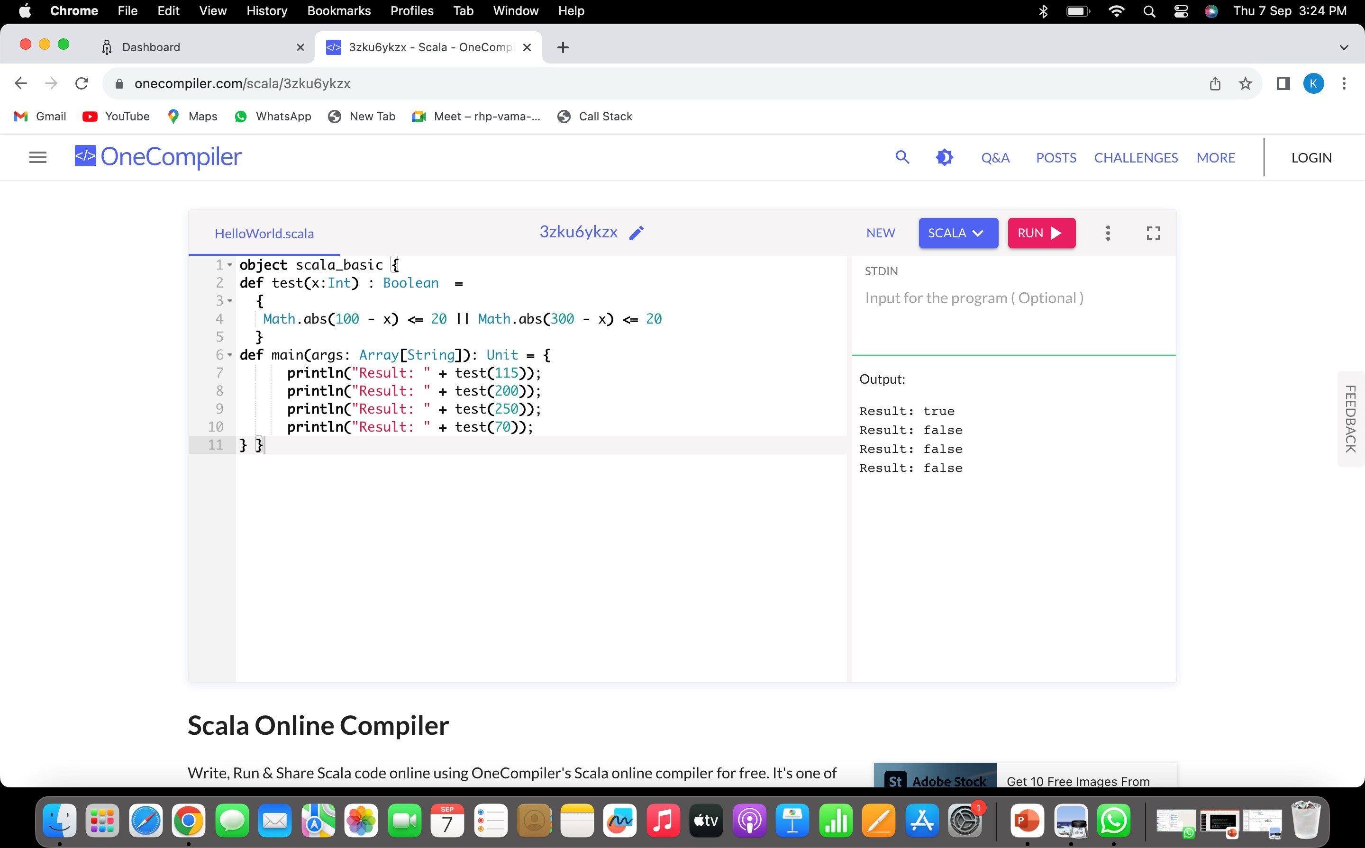

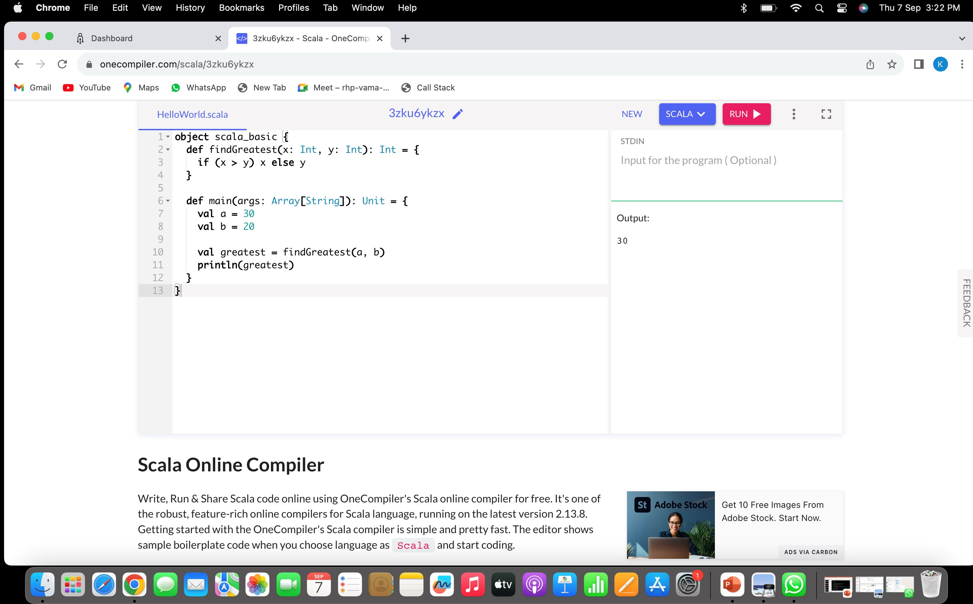

**2.write a Scala program to check a given integer and return true if it is within 20 of 100 or 300**